HP ALM

Writing test cases in Test Plan tab

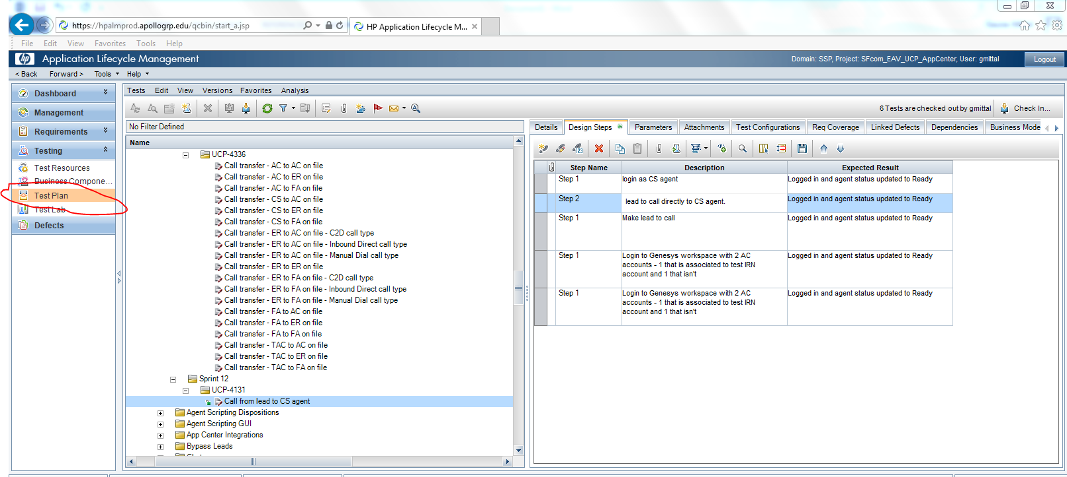

Created a folder sprint 12 then UCP-4131

Then create new test case

Start writing Steps as shown in above picture

Now click on Test Lab

There you need to create new Test Set under sprint 12.

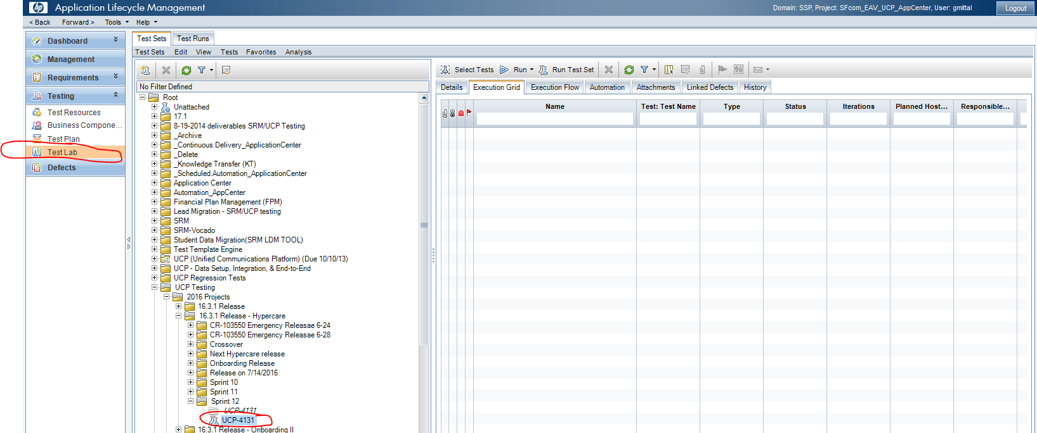

Now click on select tests

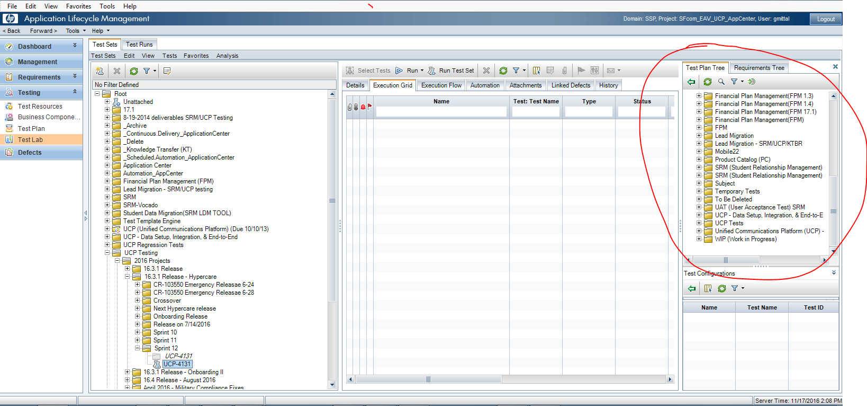

Above red highlighted red colored chunk from test plan will appear

Select you already written test cases from here

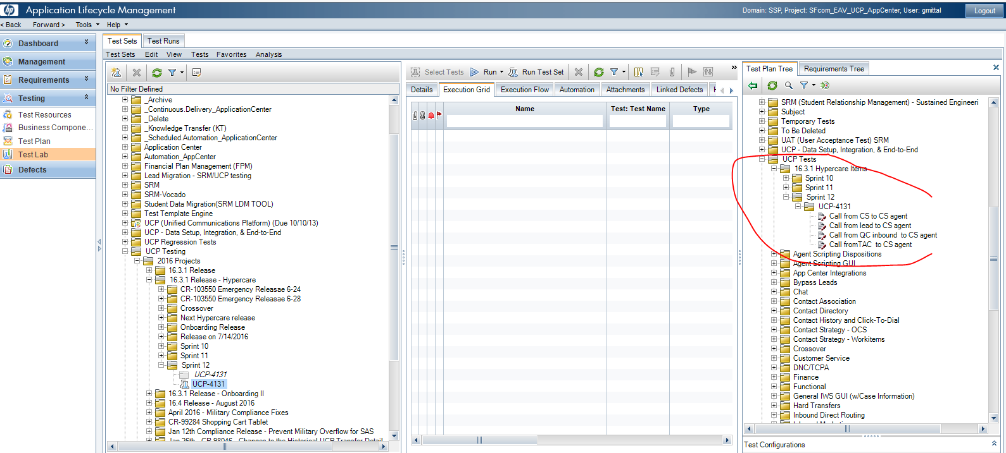

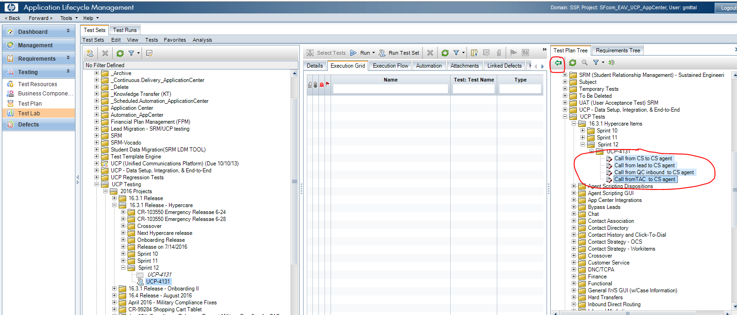

Select all test cases and click on red colored marked arrow button

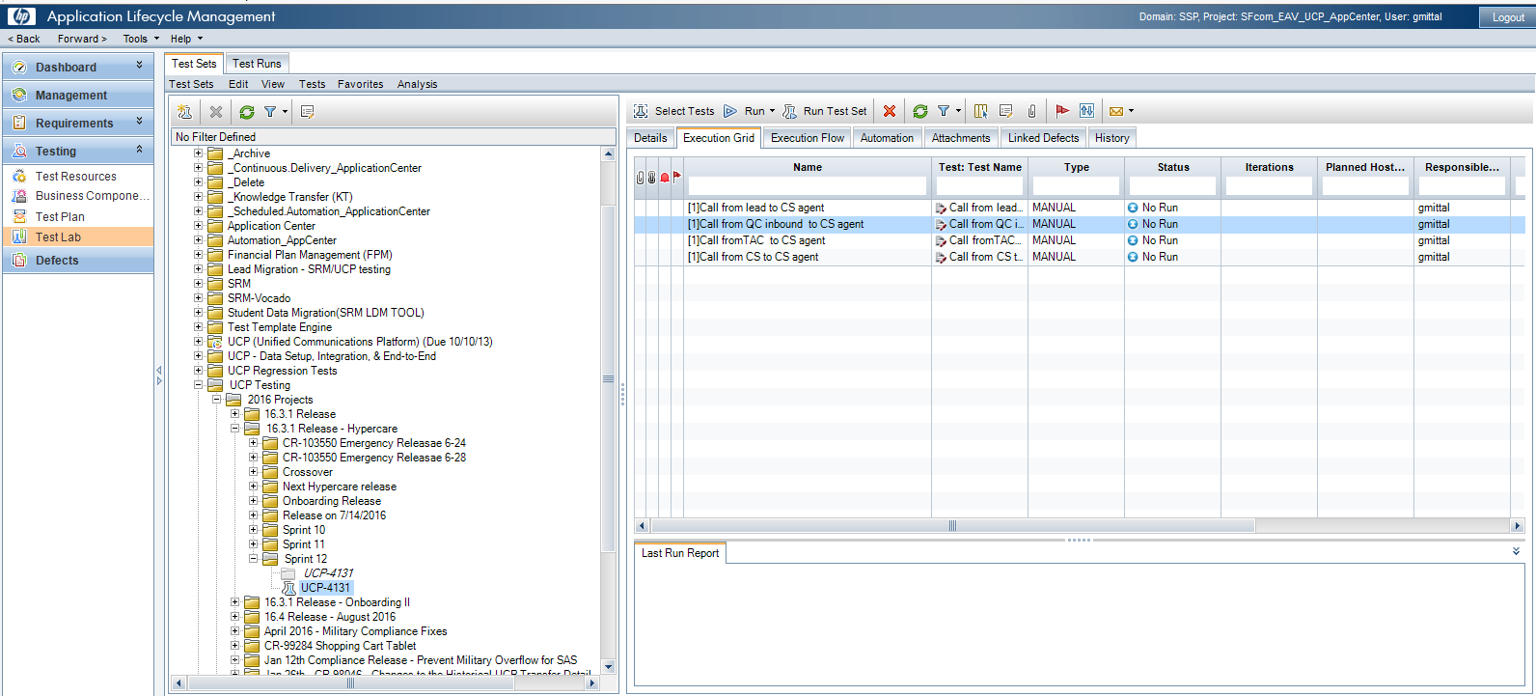

Click on run

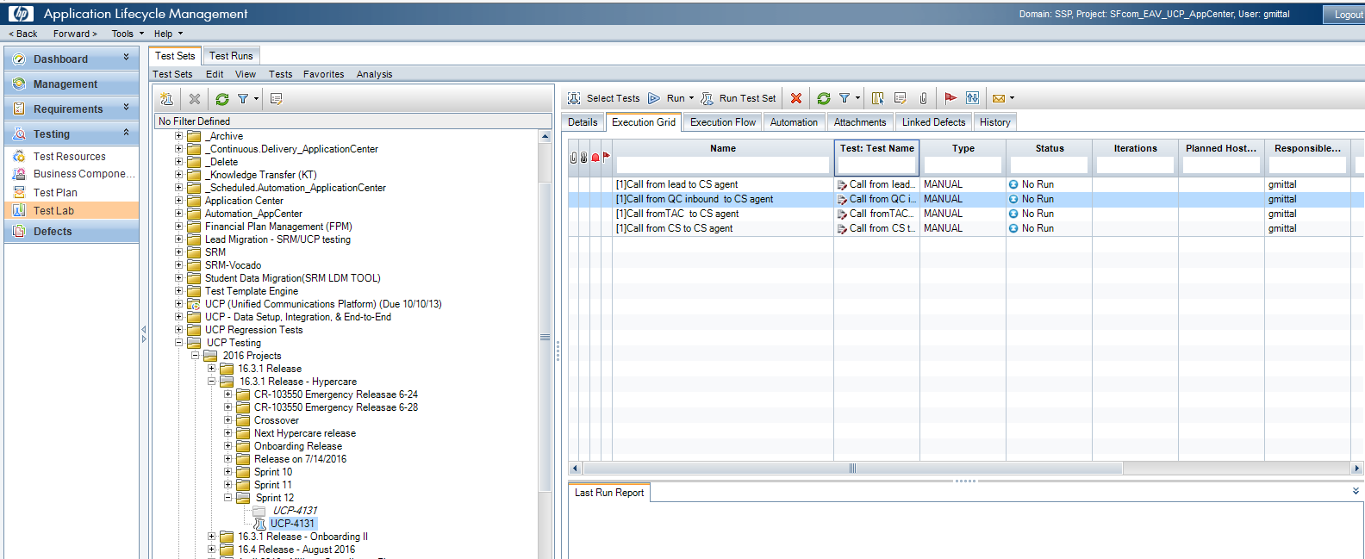

Click on run test set

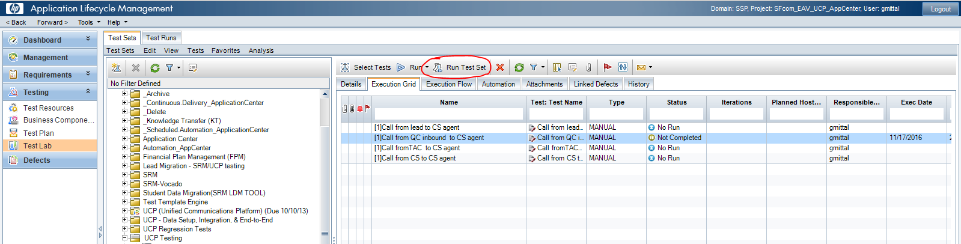

It will open windows like

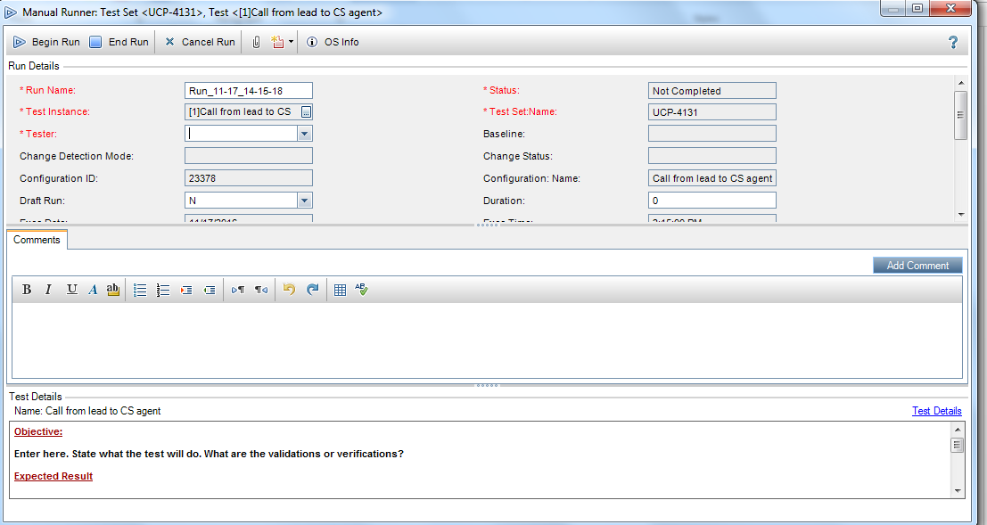

Click on begin run and it will open a window like

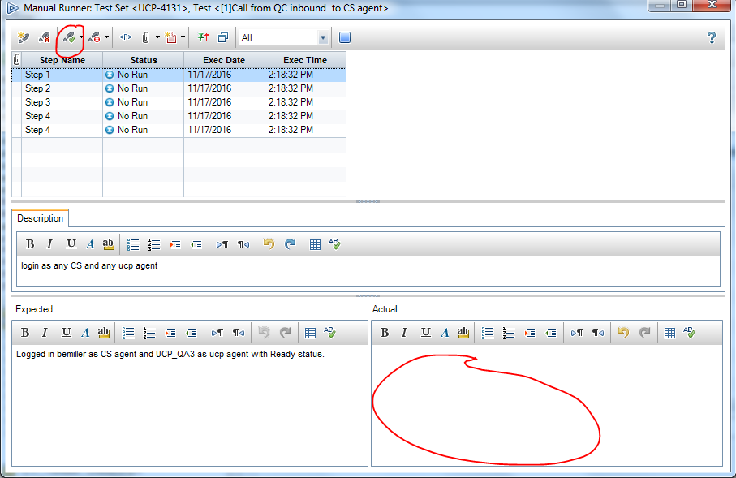

Here in actual you need to write your notes and click on pass or fail.

I have highlighted pass button.